**Assignment-3**

|  |  |
| --- | --- |
| **Student Name** | TAMIM HOSSAIN |
| **Unit Number and Title** | ACWD Module 4 – Database Design & Implementation |
| **Academic Year** | 2022 |
| **Unit Assessor** | ARVINDER KAUR |
| **Project Title** | Implement a Database Design for Community Portal |
| **Issue Date** | 31-07-2022 |
| **Submission Date** | 3-08-2022 |
| **Internal Verifier Name** |  |

|  |
| --- |
| Learner declaration |
| I certify that the work submitted for this assignment is my own and research sources are fully acknowledged.  Student signature: Date:3-08-2022 |

**Submission Format**

1. Screen Capture of Sample Data for Report
2. Queries for generating reports from database
3. Detailed Description of Test Methods
4. Documentation of database

**The scope of this assignment**

1. Create test data for all tables suitable for generating reports
2. Design report and create queries which will be used for generation of meaningful management reports. Present the report in HTML format (1 report)
3. Discuss briefly test methods you will employ to test and validate the database and brief reason why choose each test
4. Document database
5. Create a batch script to backup database & schedule it to run every 6 hours using windows task scheduler. Provide the script, along with the screen capture of Windows Task Scheduler
6. Provide a Restoration script in case of failure
7. **Create test data for all tables suitable for generating reports**

|  |  |
| --- | --- |
| **Table** | Admin |
| **SQL Query** | INSERT INTO `admin_tbl` (`admin_id`, `admin_name`, `admin_email`, `admin_password`) VALUES  (1, 'Shudipto Hasan', 'Khaledkhan32@gmail.com', '112233Sudipto+'),  (2, 'Sudipto chanda Niloy', 'sdp32548@gmail.com', 'Dipto12345roxx'),  (3, 'Akib Al Tanin', 'Akibaltanin42@gmail.com', 'vuti987654-=+'),  (4, 'Masum Ahmed', 'mahmed3215@gmail.com', 'master-masum21356'); |
|  |  |
|  | Bulk Email |
| **SQL**  **Query** | INSERT INTO `bulk_email_tbl` (`bulk_email_id`, `bulk_email`, `bulk_email_type`, `admin_id`) VALUES  (1, 'Register with Abc Job portal. To register, fill out the personal details requested on the registration form and submit by clicking on “Sign Up.” An account is automatically created, and the user can create a marketing email campaign.\r\nHere we are offering u something you might like', 'Promotional ', 1),  (2, 'Register with SendPulse. To register, fill out the personal details requested on the registration form and submit by clicking on “Sign Up.” An account is automatically created, and the user can create a marketing email campaign.', 'Promotional', 2),  (3, 'Thank you for your registration in ABC job portal here you will find a link use that to give your external details...\r\nThen simply log in...\r\nWelcome to ABC Job portal', 'registration', 3),  (4, 'Welcome To ABC job portal hope your upcoming days will go well with us...\r\nHere you will find the news latter\r\nKindly please refer this and explain us your choice of interest', 'Newsletter', 4); |
|  |  |
|  | Company |
| **SQL**  **Query** | INSERT INTO `company_tbl` (`company_id`, `company_name`, `location`, `website_link`, `contact`) VALUES  (1, 'Oracle.com', 'Hampson Rever,1234 street lake view park', 'https://www.oracle.com', '+8801716605265'),  (2, 'google.com', 'Lake view park ,$325 road ', 'www.google.com', '+96340988234734'),  (3, 'Unsplash.com', 'Lylen street,23 criest charce ', 'https://unsplash.com/s/photos/study', '+78786565765'),  (4, 'Git Hub', 'river side port cleopetry', 'https://github.com', '+9875463225'); |
|  |  |
|  | Apply Jobs |
| **SQL**  **Query** | INSERT INTO `apply_jobs_tbl` (`apply_job_id`, `job_id`, `position`) VALUES  (1, 1, 'Software developer'),  (2, 2, 'Full stack developer'),  (3, 3, 'Front end developer'),  (4, 4, 'Back end developer'); |
|  |  |
|  | Jobs |
| **SQL**  **Query** | INSERT INTO `jobs_tbl` (`jobs_id`, `company_id`, `deadline_of_Application`, `job_position`, `salary`, `user_id`) VALUES  (1, 1, '2022-07-07', 'Software developer', 1400, 1),  (2, 2, '2022-07-02', 'Full stack developer ', 1500, 2),  (3, 3, '2022-07-02', 'Front end developer', 1100, 3),  (4, 4, '2022-07-31', 'Back end Developer', 1200, 4); |
|  |  |
|  | Log in |
| **SQL**  **Query** | INSERT INTO `log_in_tbl` (`log_in_id`, `user_id`, `user_name`, `email`, `password`) VALUES  (1, 1, 'afnansayed0145', 'asayed0245126@hmail.com', '3678867465kj'),  (2, 2, 'angryqueen8970', 'aQ@koutlook@com', 'lkkjhg76it5'),  (3, 3, 'gazifar453', 'Gfra0982hmail.com', '3699886jhsghjhs'),  (4, 4, 'rimaislam0987', 'rms@gmail.com', 'jkhjmghfg98'); |
|  |  |
|  | Send Messages |
| **SQL**  **Query** | INSERT INTO `send_messages_table` (`send_messages_id`, `text`, `user_id`, `time`) VALUES  (1, 'I like the way you talk, I like the things you wear\r\nI want your number tattooed on my arm in ink, I swear\r\n\'Cause when the morning comes, I know you won\'t be there\r\nEvery time I turn around, you disappear\r\nI wanna blow your mind, just come with me, I swear\r\nI\'m gonna take you somewhere warm, you know j\'adore la mer\r\n\'Cause when the morning comes, I know you won\'t be there\r\nEvery time I turn around, you disappear', 1, '16:00:00'),  (2, 'I like the way you talk, I like the things you wear\r\nI want your number tattooed on my arm in ink, I swear\r\n\'Cause when the morning comes, I know you won\'t be there\r\nEvery time I turn around, you disappear\r\nI wanna blow your mind, just come with me, I swear\r\nI\'m gonna take you somewhere warm, you know j\'adore la mer\r\n\'Cause when the morning comes, I know you won\'t be there\r\nEvery time I turn around, you disappear', 2, '12:20:30'),  (3, '\r\nI\'m gonna take you somewhere warm, you know j\'adore la mer\r\n\'Cause when the morning comes, I know you won\'t be there\r\nEvery time I turn around, you disappear', 3, '04:22:54'),  (4, '\r\nI\'m gonna take you somewhere warm, you know j\'adore la mer\r\n\'Cause when the morning comes, I know you won\'t be there\r\nEvery time I turn around, you disappear', 3, '06:22:54'); |
|  |  |
|  | Read Messages |
| **SQL**  **Query** | INSERT INTO `read_messages_tbl` (`read_messages_id`, `text`, `user_id`, `time`) VALUES  (2, 'Hola, comment allez, allez-vous?\r\nSo nice to meet ya\r\nYou say we should go and get a room (no)\r\nIf you wanna turn it on\r\nGo, get a lightbulb, después hablamos\r\nIf you wanna turn it on\r\nGo, get a lighter, después bailamos\r\nOh, un, dos, tres\r\nUn, dos, tres\r\nSi te doy un beso ya estás a mis pies\r\nDime un, dos, tres\r\nUn, dos, tres\r\nLa, la, la, la, la', 1, '08:31:25'),  (3, 'Hola, comment allez, allez-vous?\r\nSo nice to meet ya\r\nYou say we should go and get a room (no)\r\nIf you wanna turn it on\r\nGo, get a lightbulb, después hablamos\r\nIf you wanna turn it on\r\nGo, get a lighter, después bailamos\r\nOh, un, dos, tres\r\nUn, dos, tres\r\nSi te doy un beso ya estás a mis pies\r\nDime un, dos, tres\r\nUn, dos, tres\r\nLa, la, la, la, la', 2, '16:00:00'),  (4, 'Hola, comment allez, allez-vous?\r\nSo nice to meet ya\r\nYou say we should go and get a room (no)\r\nIf you wanna turn it on\r\nGo, get a lightbulb, después hablamos\r\nIf you wanna turn it on\r\nGo, get a lighter, después bailamos\r\nOh, un, dos, tres\r\nUn, dos, tres\r\nSi te doy un beso ya estás a mis pies\r\nDime un, dos, tres\r\nUn, dos, tres\r\nLa, la, la, la, la', 3, '21:47:18'),  (5, 'Hola, comment allez, allez-vous?\r\nSo nice to meet ya\r\nYou say we should go and get a room (no)\r\nIf you wanna turn it on\r\nGo, get a lightbulb, después hablamos\r\nIf you wanna turn it on\r\nGo, get a lighter, después bailamos\r\nOh, un, dos, tres\r\nUn, dos, tres\r\nSi te doy un beso ya estás a mis pies\r\nDime un, dos, tres\r\nUn, dos, tres\r\nLa, la, la, la, la', 4, '05:22:09'); |
|  |  |
|  | Profile |
| **SQL**  **Query** | INSERT INTO `profile_tbl` (`profile_id`, `work_llinks`, `skills`, `user_id`, `name`, `email`, `phone`, `profession`) VALUES  (1, 'google.com', 'Software_developer', 1, 'Afnan Sayed', 'Afs@hotmail.com', '+880015698656', 'Former Software Engineer Oracle'),  (2, 'Oracle.com', 'Designer', 2, 'Rima Islam', 'rms43@hotmail.com', '+98765434', 'Former Data engineer And Designer'),  (3, 'javaTpoint.com', 'Backend developer', 3, 'Gazi fariya', 'Fragin@hotmail.com', '+56987236545', 'Web_developer.Data Advocate'),  (4, 'geeksforgeeks.com', 'Data entry and web design', 4, 'Angry Queen', 'angryqueen43@gmail.com', '+003698254211', 'Full stack developer at Google'); |
|  |  |
|  | Registration form |
| **SQL**  **Query** | INSERT INTO `registration_form_tbl` (`regi_id`, `resistration _id`, `first_name`, `last_name`, `birth_day`, `gender`, `phone`, `country`, `city`) VALUES  (1, 1, 'Tamim', 'Hossain', '2012-07-01', 'Male', '+8801716605', 'Bangladesh', 'Chandpur'),  (2, 2, 'Any', 'One', '2012-07-05', 'Female', '+098765432', 'India', 'punjab'),  (3, 3, 'No ', 'One', '2022-07-01', 'Female', '+896541223655', 'canada', 'Toronto'),  (4, 4, 'Hasaranga', 'Wanindu', '2022-07-01', 'Male', '+056987452', 'Sri Lanka', 'Bandarawela'); |
|  |  |
|  | Account |
| **SQL**  **Query** | INSERT INTO `account_tbl` (`registration_id`, `user_id`, `user_name`, `email`, `password`) VALUES  (1, 1, 'Afnan_Sayed4234', 'afsayed65@hotmail.com', '654654655'),  (2, 2, 'rimaislam98 ', 'rimaislam1@outlook.com', '635346646an94'),  (3, 3, 'gazifr6590', 'gazifariya43@protonmail.com', '3545648noahg'),  (4, 4, 'AngryQueen100 ', 'aqueen98@hotmail.com', 'typhoon6578'); |
|  |  |
|  | Update Profile |
| **SQL**  **Query** | INSERT INTO `update_profile_tbl` (`update_id`, `profile_id`) VALUES  (3, 1),  (4, 2),  (2, 3),  (1, 4); |
|  |  |
|  | User |
| **SQL**  **Query** | INSERT INTO `user_tbl` (`user_id`, `user_name`, `user_email`) VALUES  (1, 'Afnan_sayed4234', 'afsayed65@hotmail.com'),  (2, 'rimaislam98', 'rimaislam1@outlook.com'),  (3, 'gazifr6590', 'gazifariya43@protonmail.com'),  (4, 'AngryQueen100', 'aqueen98@hotmail.com'); |
|  |  |

1. **Design report and create queries which will be used for generation of meaningful management reports.**

**registration_form_tbl Table…**

|  |  |  |  |
| --- | --- | --- | --- |
| No | Note | Query | Evidence |
| 1 | All users personal details info.  To fetch users, registration information | SELECT regi_id, CONCAT(first_name, ' ',last_name) AS name, birth_day, gender,phone, CONCAT(city, ', ',country) AS location FROM registration_form_tbl ORDER BY name; | Report users contact log |

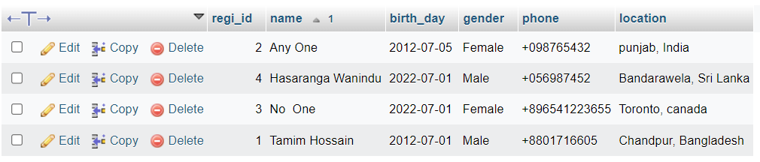

**company_tbl Table**

|  |  |  |  |
| --- | --- | --- | --- |
| No | Note | Query | Evidence |
| 2 | Company website3 link and phone number added as location | SELECT company_id, CONCAT(website_link, ' ',contact) AS contact FROM company_tbl ORDER BY contact; | Report company contact log |

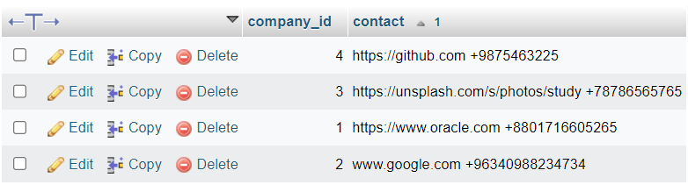

**profile_tbl Table**

|  |  |  |  |
| --- | --- | --- | --- |
| No | Note | Query | Evidence |
| 3 | Profile skill and profession listed as works and email & phone listed as contacts. | SELECT profile_id, CONCAT(skills, ' ',profession) AS works, name, CONCAT(email, ', ',phone) AS Contact  FROM profile_tbl ORDER BY name; | Report profile user works details and user contact log |

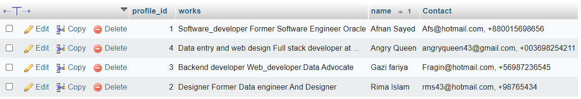

**Update_profile_tbl Table**

|  |  |  |  |
| --- | --- | --- | --- |
| No | Note | Query | Evidence |
| 4 | Profile skill and profession listed as works and email & phone listed as contacts. | SELECT update_id, CONCAT(email, ' ',phone)  AS contact_details,  name, profession,user_profile_pic  FROM update_profile_tbl  ORDER BY name; | Report profile user works details and user contact log |

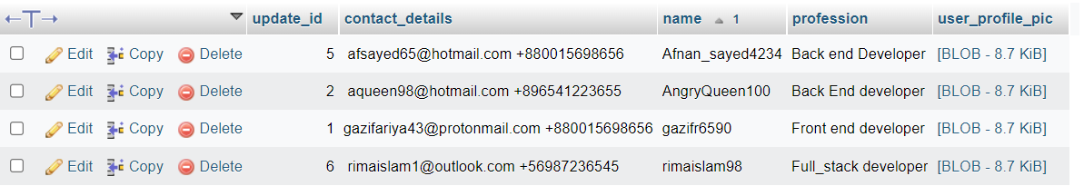

bulk_email_tbl

|  |  |  |  |
| --- | --- | --- | --- |
| No | Note | Query | Evidence |
| 5 | Bulk emails email and it types executed as bulk email details | SELECT bulk_email_id, CONCAT(bulk_email, ' ',bulk_email_type) AS email_details FROM bulk_email_tbl ORDER BY admin_id; | Email and email types are working as email details |

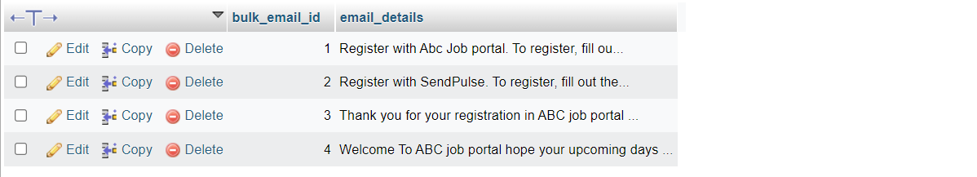

1. **Discuss briefly test methods you will employ to test and validate the database and brief reason why choose each test**
2. **Structural Database Testing**
   1. **Schema Testing.**

Schema or database testing is vital in ensuring the validity of data received and stored into database.

|  |  |  |  |  |
| --- | --- | --- | --- | --- |
| No. / Test Cases | Expected Result | Actual Result | Test Result | Evidence |
| 1. Schema Testing: Ensure that Relationship Schema and EER Diagram is the same in terms of (table name, attributes, primary key and foreign key) | Both Relationship schema and EER diagram should have similar field of: table name, attributes, primary key and foreign key | Both Relationship schema and EER diagram is the same in terms of (table name, attributes, primary key and foreign key)  *See diagram in next page | Pass | Screen capture of logical design and physical design (EERD) |

**Evidence:**

Relationship Schema  
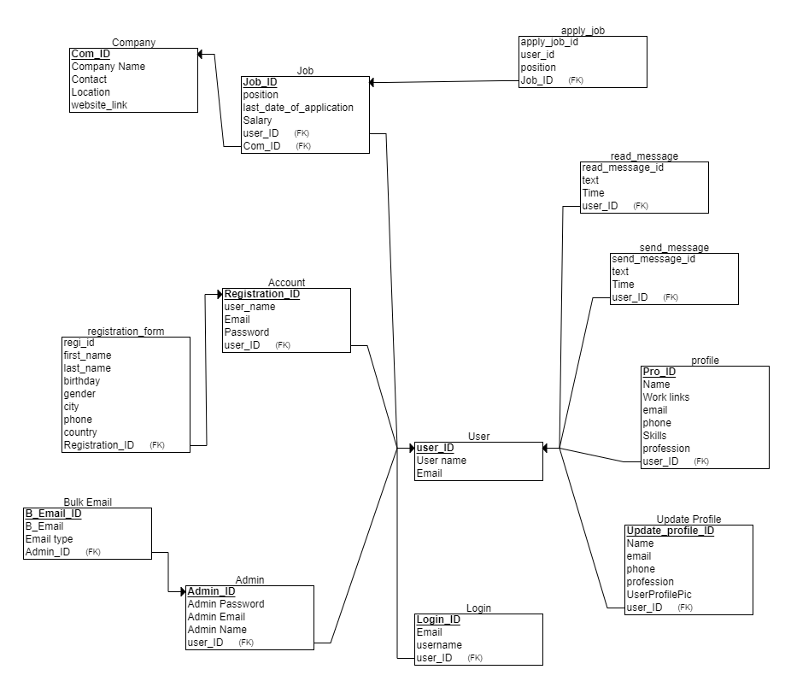

EER Diagram

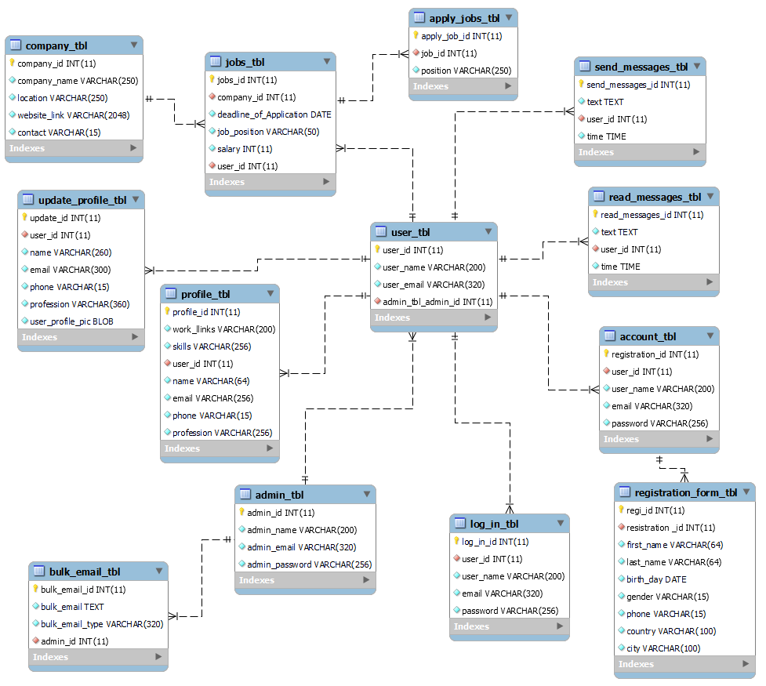

* 1. **Table/column testing.**

Every transaction or sequence of operations performed using SQL statement must conform to the ACID properties validation…

**Table/columns testing**

|  |  |  |  |  |  |
| --- | --- | --- | --- | --- | --- |
| TestCase ID | Test case | Expected result | Actual result | Pass / Fail | Evidence |
| TC01 | 1. Primary Key testing: Insert duplicate value for primary key column for ‘user_tbl’ table | Error message should appear because duplicate value will be inserted into primary key column violating the rule | Error message appear because duplicate value is inserted into primary key column | Pass | Evidence screen capture No TC01 |
| TC02 | 1. Primary Key testing: Insert duplicate value for primary key column for ‘admin_tbl’ table | Error message should appear because duplicate value will be inserted into primary key column violating the rule | Error message appear because duplicate value is inserted into primary key column | Pass | Evidence screen capture No TC02 |
| TC03 | 1. Primary Key testing: Insert duplicate value for primary key column for ‘account_tbl’ table | Error message should appear because duplicate value will be inserted into primary key column violating the rule | Error message appear because duplicate value is inserted into primary key column | Pass | Evidence screen capture No TC03 |
| TC04 | 1. Primary Key testing: Insert duplicate value for primary key column for ‘apply_job_tbl’ table | Error message should appear because duplicate value will be inserted into primary key column violating the rule | Error message appear because duplicate value is inserted into primary key column | Pass | Evidence screen capture No TC04 |
| TC05 | 1. Primary Key testing: Insert duplicate value for primary key column for ‘company_tbl’ table | Error message should appear because duplicate value will be inserted into primary key column violating the rule | Error message appear because duplicate value is inserted into primary key column | Pass | Evidence screen capture No TC05 |

**TC01**

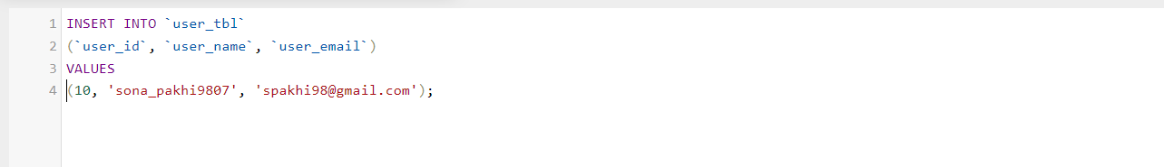

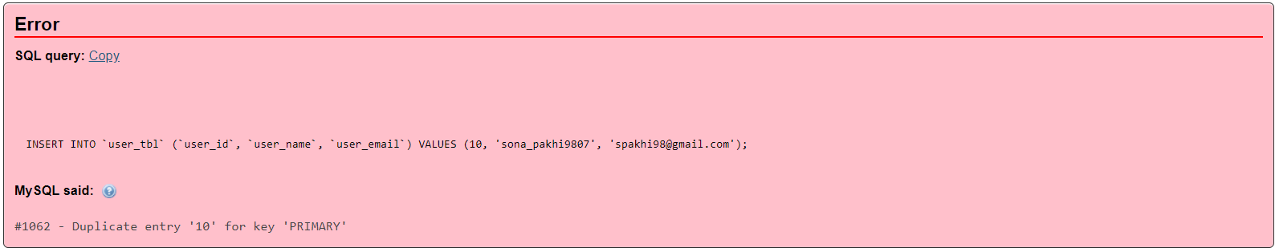

SQL Query below shows that the next increment value is 11. Hence, User_ID is auto incrementing.

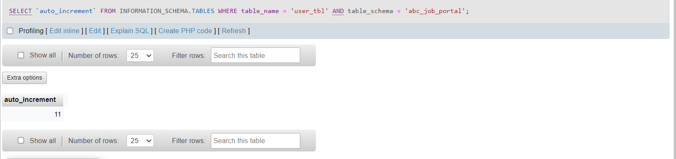

**TC02**

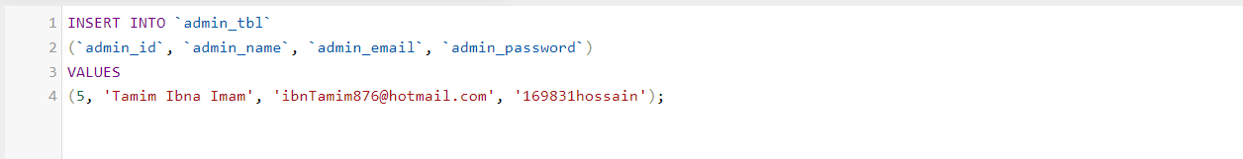

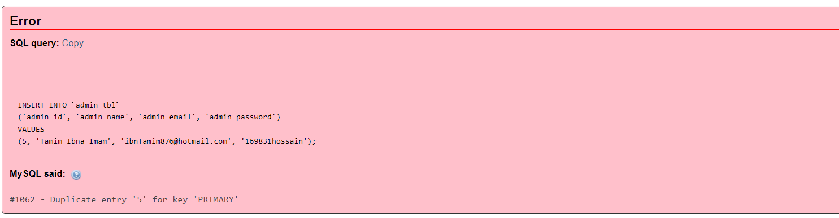

SQL Query below shows that the next increment value is 7. Hence, admin_ID is auto incrementing.

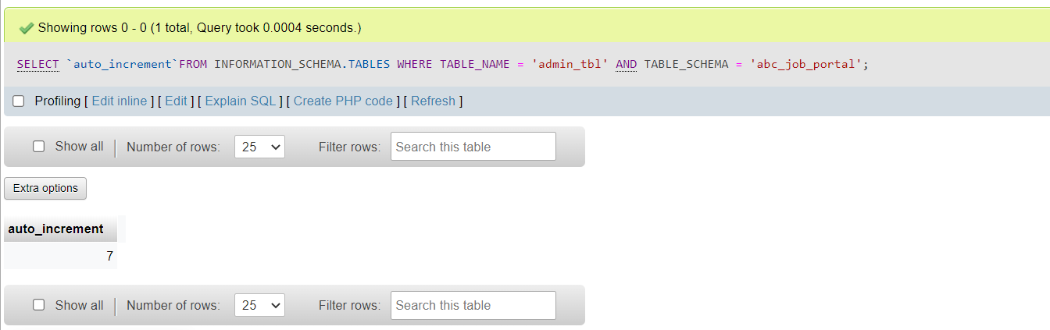

TC03

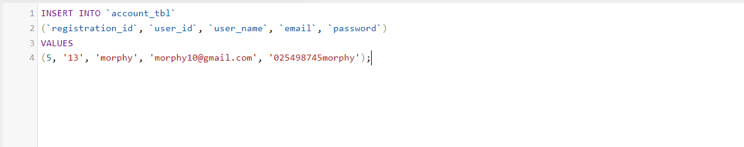

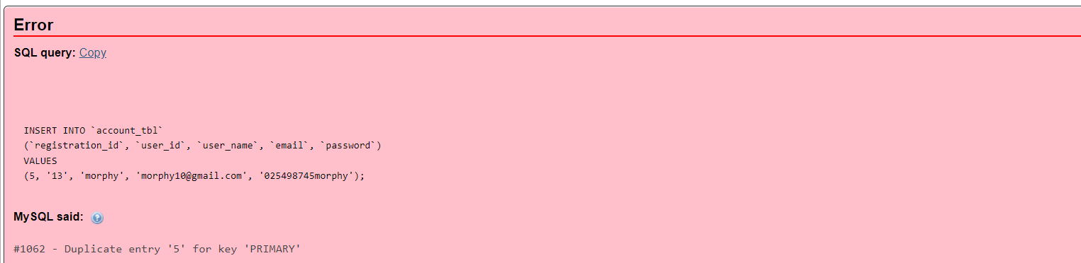

SQL Query below shows that the next increment value is 6. Hence, registration_ID is auto incrementing.

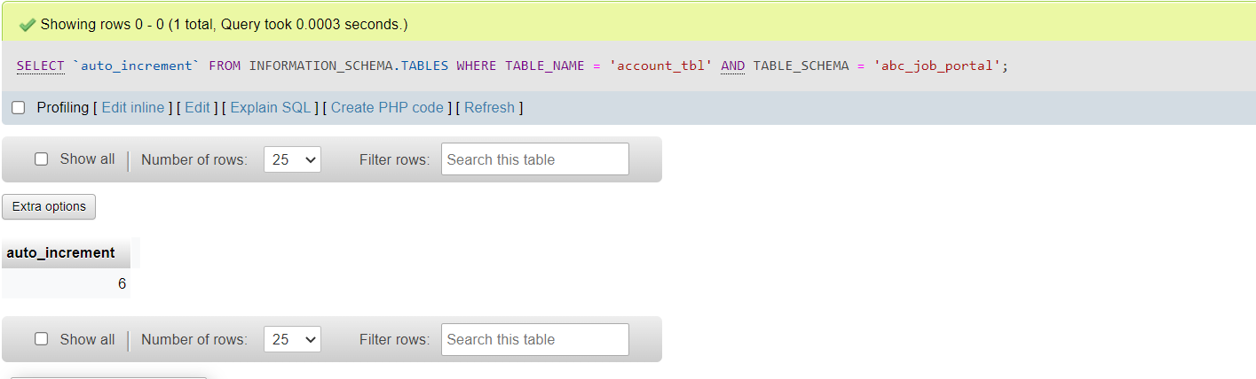

TC04

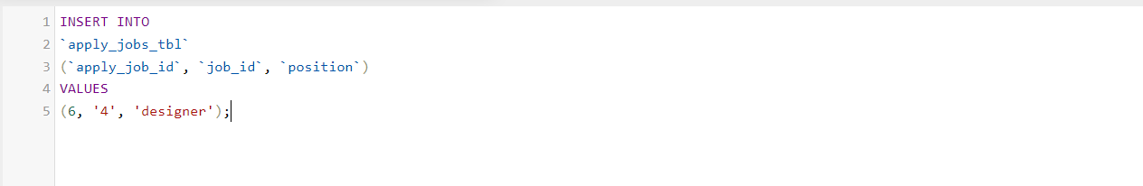

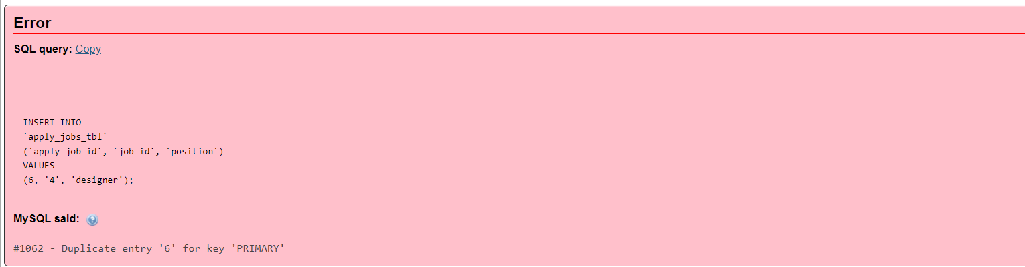

SQL Query below shows that the next increment value is 7. Hence, apply_job_ID is auto incrementing.

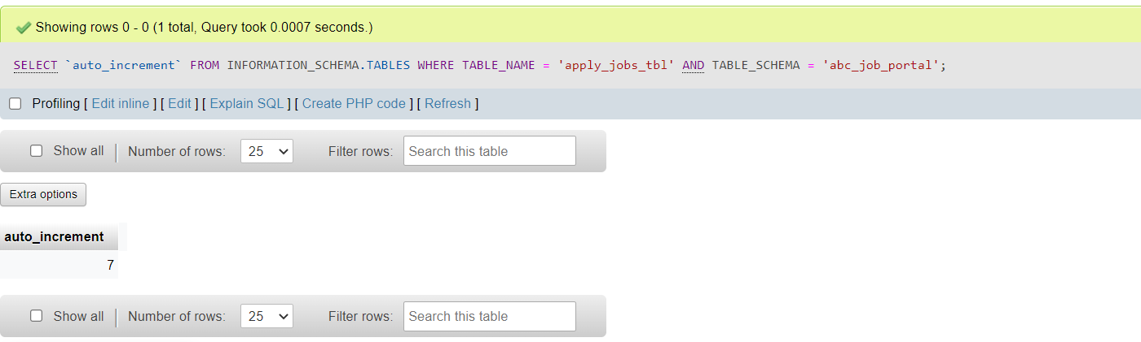

TC05

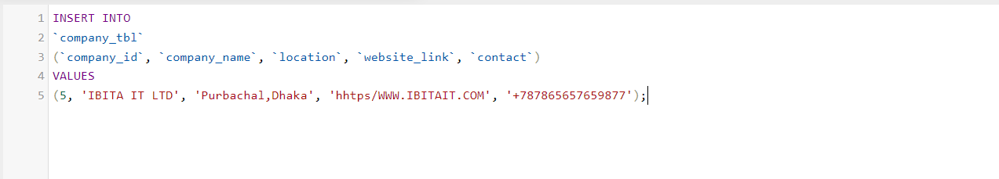

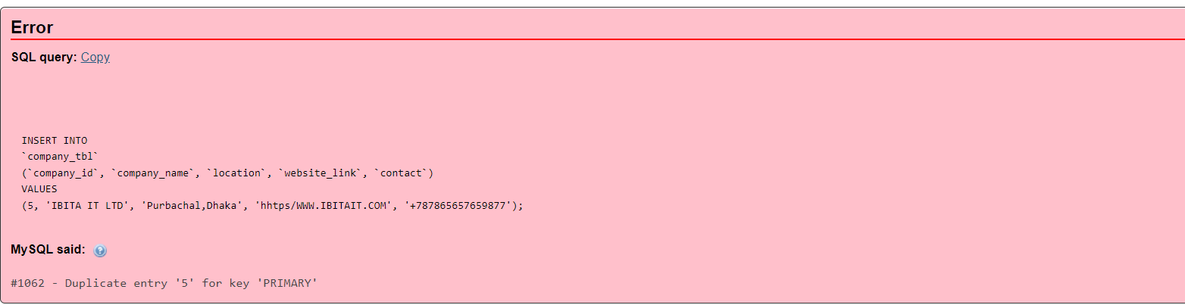

SQL Query below shows that the next increment value is 6. Hence, company_ID is auto incrementing.

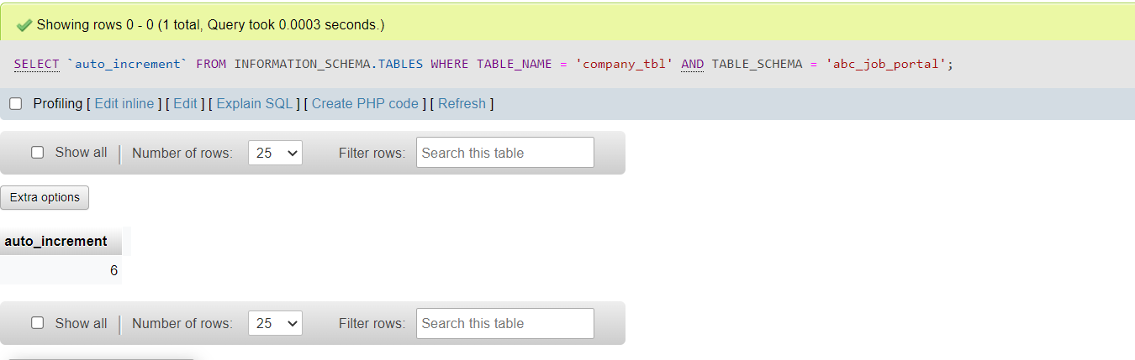

1. **Functional Database Testing**

Functional database testing is to test whether data in the database can be access and updated by the users and applications. all CRUD

**User_tbl**

|  |  |  |  |  |  |
| --- | --- | --- | --- | --- | --- |
| TestCase ID | Test Case | Expected Result | Actual Result | Test Result | Evidence |
| FC001 | 1. Insert record into ‘user_tbl’ table | A record should successfully insert into 'user_tbl' table. | Record is successfully inserted into ‘user_tbl’ table | Pass | FC001 Fig |
| FC002 | 2. view record into ‘user_tbl’ table | A browsing view should successfully shown of 'user_tbl' table. | Showing rows 0-4 | pass | FC002 Fig |
| FC003 | 3. update record into ‘user_tbl’ table | A record should successfully updated into 'user_tbl' table. | Record is successfully updated into ‘user_tbl’ table | pass | FC003 Fig |
| FC004 | 4. Delete record into ‘user_tbl’ table | A record should successfully deleted into 'user_tbl' table. | Record is successfully deleted into ‘user_tbl’ table | pass | FC004 Fig |

**Evidence: -**

**FC001**

**create**

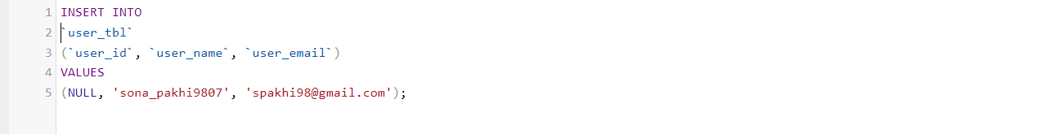

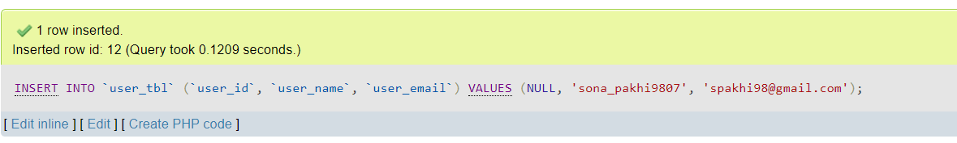

**FC002**

Read



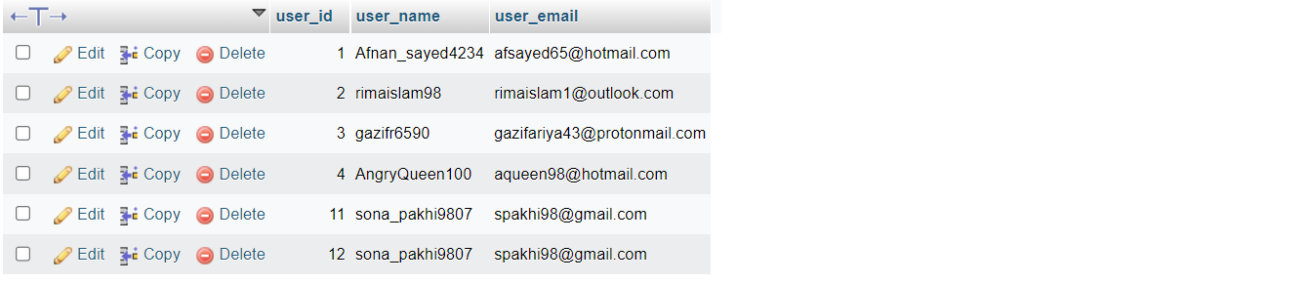

FC003

Update

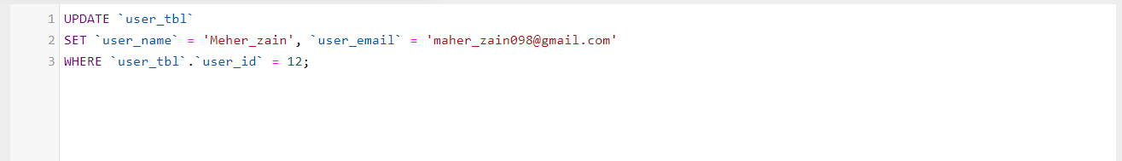

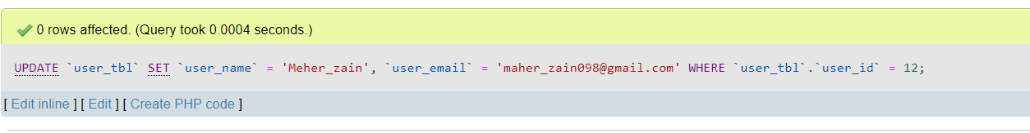

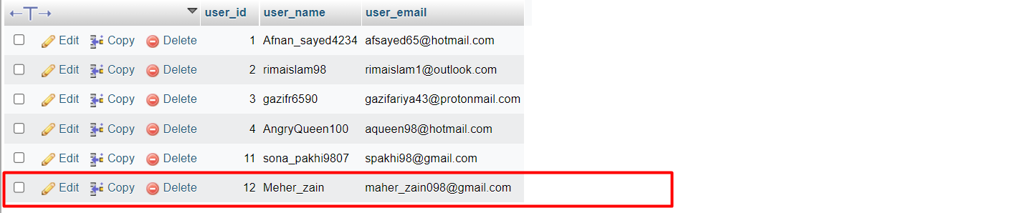

FC004

Delete

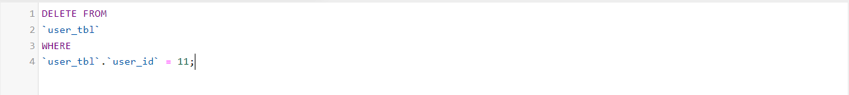

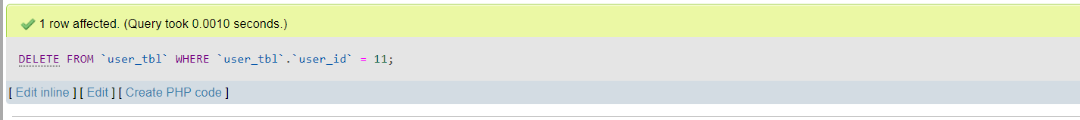

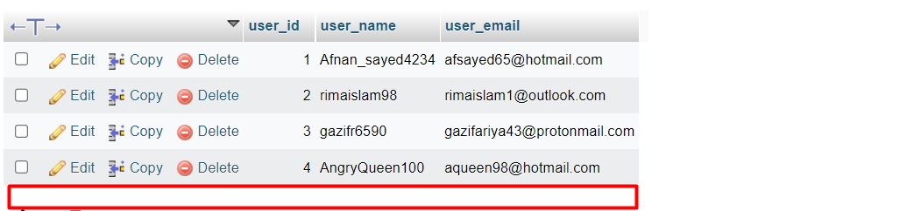

**Admin_tbl**

|  |  |  |  |  |  |
| --- | --- | --- | --- | --- | --- |
| TestCase ID | Test Case | Expected Result | Actual Result | Test Result | Evidence |
| FC001 | 1. Insert record into ‘admin_tbl’ table | A record should successfully insert into 'admin_tbl' table. | Record is successfully inserted into ‘admin_tbl’ table | Pass | FC001 Fig |
| FC002 | 2. view record into ‘admin_tbl’ table | A browsing view should successfully shown of 'user_tbl' table. | Showing rows 0-5 | pass | FC002 Fig |
| FC003 | 3. update record into ‘admin_tbl’ table | A record should successfully updated into 'admin_tbl' table. | Record is successfully updated into ‘admin_tbl’ table | pass | FC003 Fig |
| FC004 | 4. Delete record into ‘admin_tbl’ table | A record should successfully deleted into 'admin_tbl' table. | Record is successfully deleted into ‘admin_tbl’ table | pass | FC004 Fig |

FC001

Create

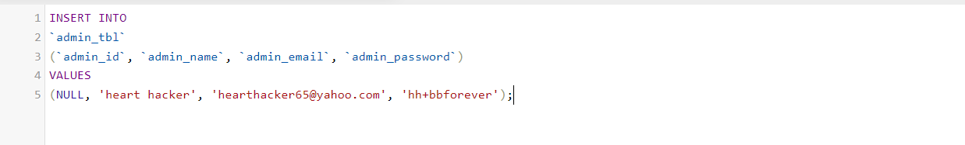



FC002

Read

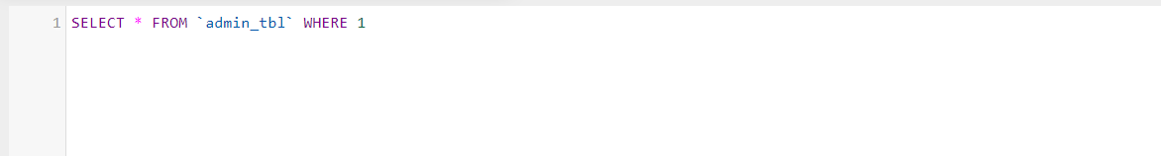

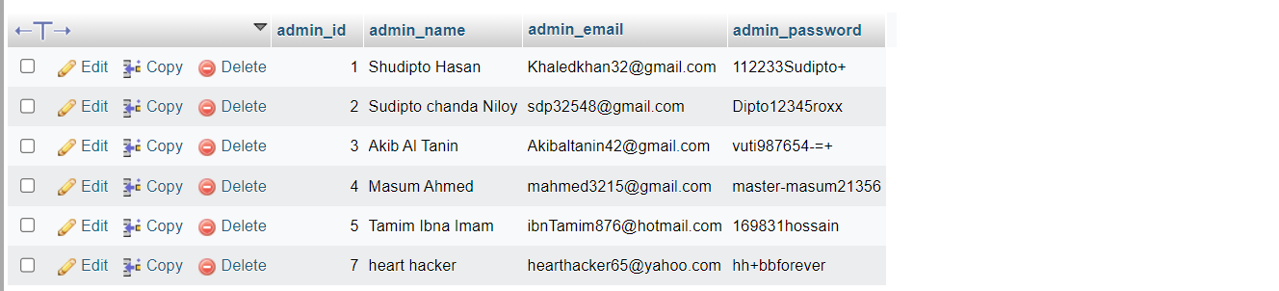

FC003

Update

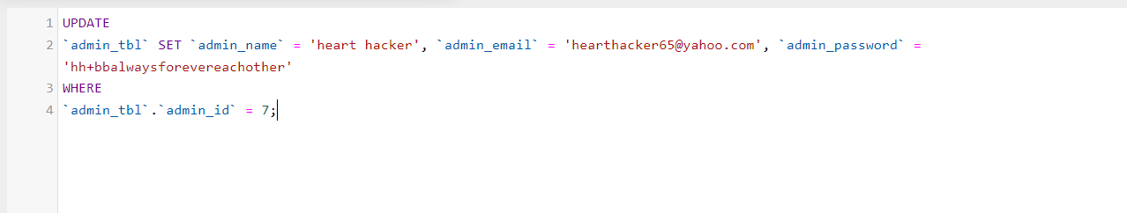

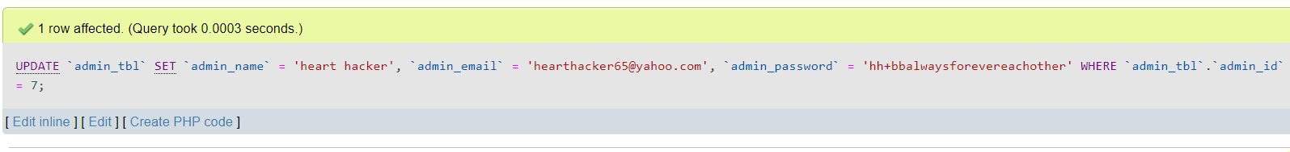

FC004

Delete

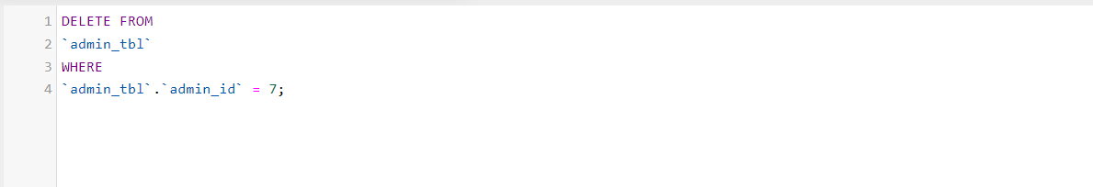



**account_tbl**

|  |  |  |  |  |  |
| --- | --- | --- | --- | --- | --- |
| TestCase ID | Test Case | Expected Result | Actual Result | Test Result | Evidence |
| FC001 | 1. Insert record into ‘account_tbl’ table | A record should successfully insert into ' account _tbl' table. | Record is successfully inserted into ‘account _tbl’ table | Pass | FC001 Fig |
| FC002 | 2. view record into ‘account _tbl’ table | A browsing view should successfully shown of ' account _tbl' table. | Showing rows 0-5 | pass | FC002 Fig |
| FC003 | 3. update record into ‘account _tbl’ table | A record should successfully updated into ' account _tbl' table. | Record is successfully updated into ‘account _tbl’ table | pass | FC003 Fig |
| FC004 | 4. Delete record into ‘account _tbl’ table | A record should successfully deleted into ' account _tbl' table. | Record is successfully deleted into ‘account _tbl’ table | pass | FC004 Fig |

FC001

Create

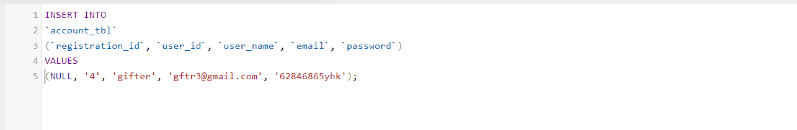



FC002

Read

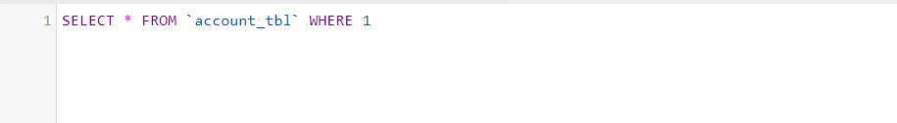

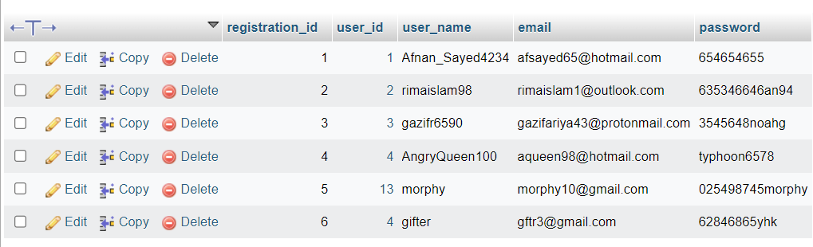

FC003

Update

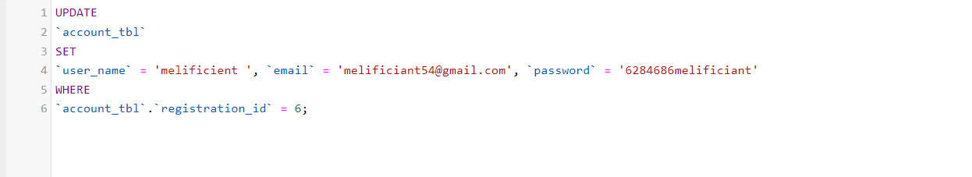



FC004

Delete

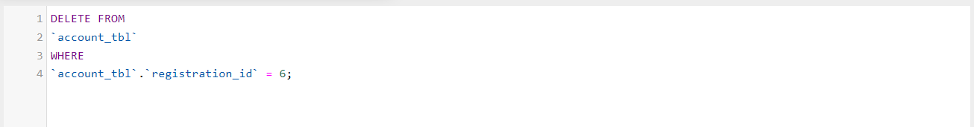



1. **Non-Functional Database**

Non – functional specify on the quality of a database characteristics or attributes based on performance, capacity, data integrity, security and more. This requirement describes more on how the product works through testing like load, stress, security and others

* 1. **Load Testing**

Load testing test frequently accessed transactions impact on the database performance.

This testing involves simulating real-life cases when multiple users load simultaneously (Database Testing – Performance, n.d.) .

**Test Plan**

|  |  |  |  |
| --- | --- | --- | --- |
| No | Test case | Note | Evidence |
| 1 | Auto generate | Test performance of the device for simple test using auto generate from the mysqlslap with 50 users and 10 repetitions. | Load test 1 |
| 2 | custom query from the auto generates | Test performance with custom query using schema from auto generate with 50 users and 10 repetitions. | Load test 2 |
| 3 | Custom test using copy of the abc database | Test performance with custom query using copy schema abc with 50 users and 30 repetitions. | Load test 3 |

**Load test 1**

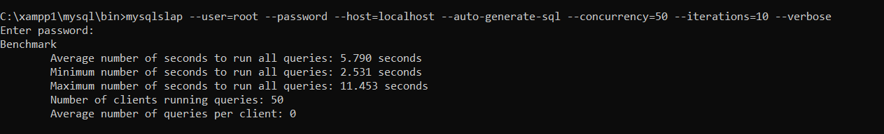

**Load test 2**

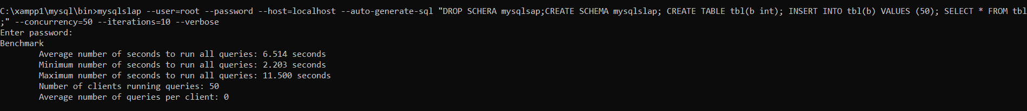

**Load test 3**



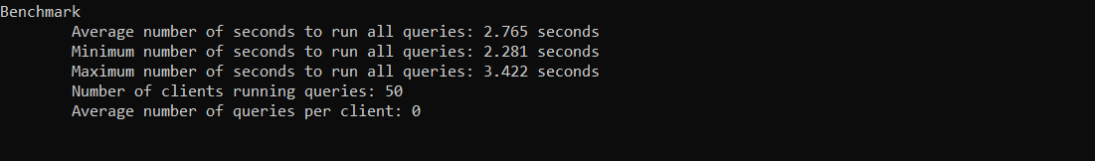

1. **Document Database**

**Abc_job_portal Database** 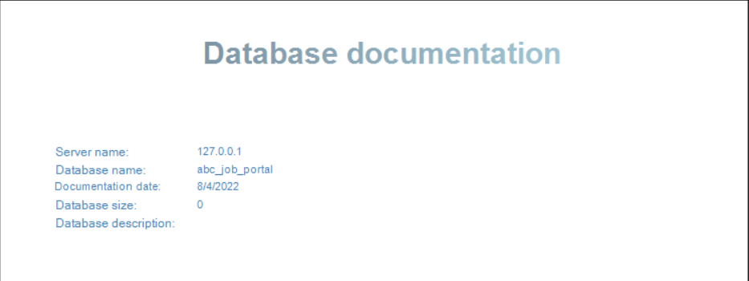

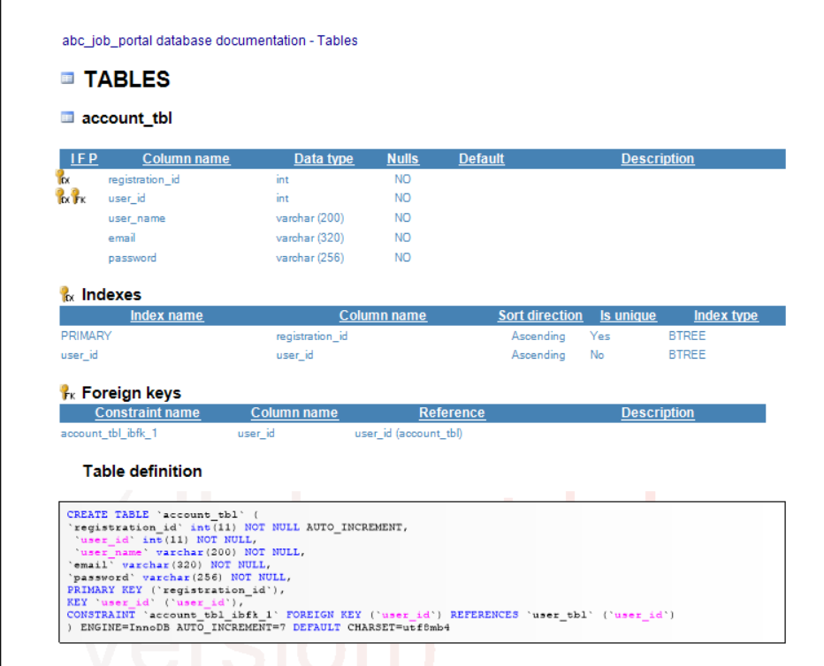

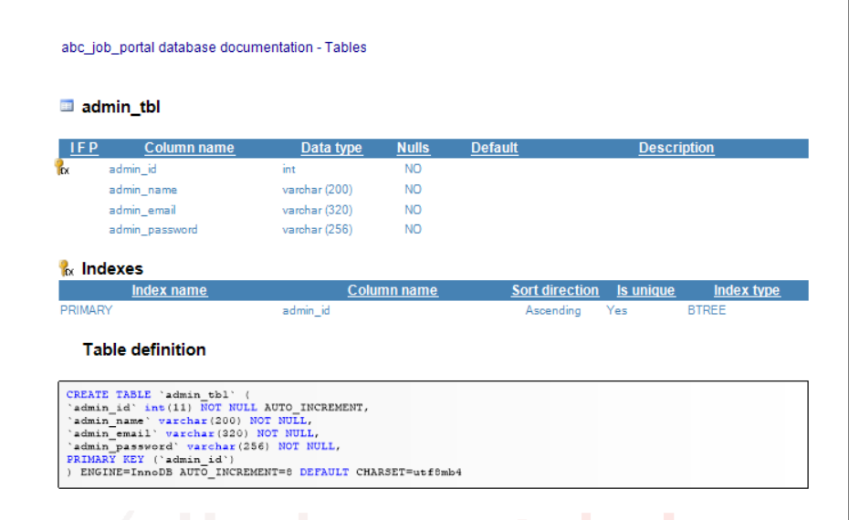

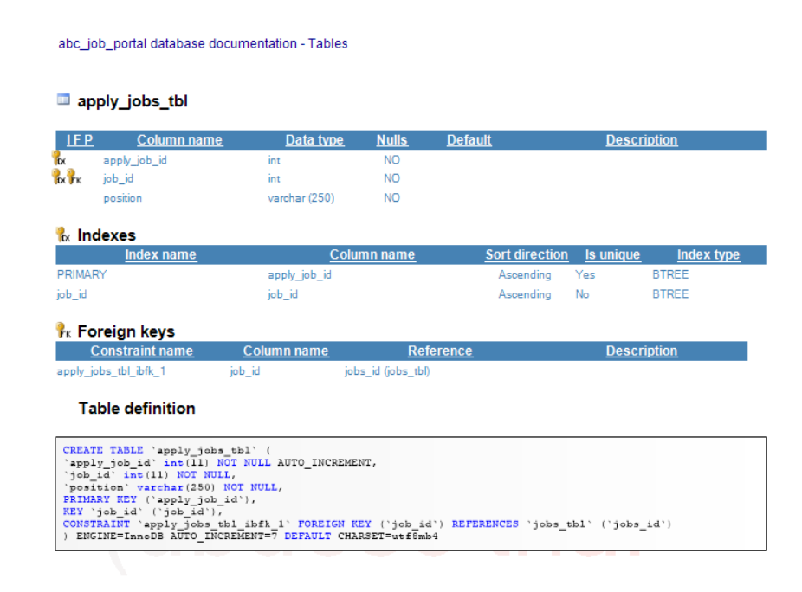

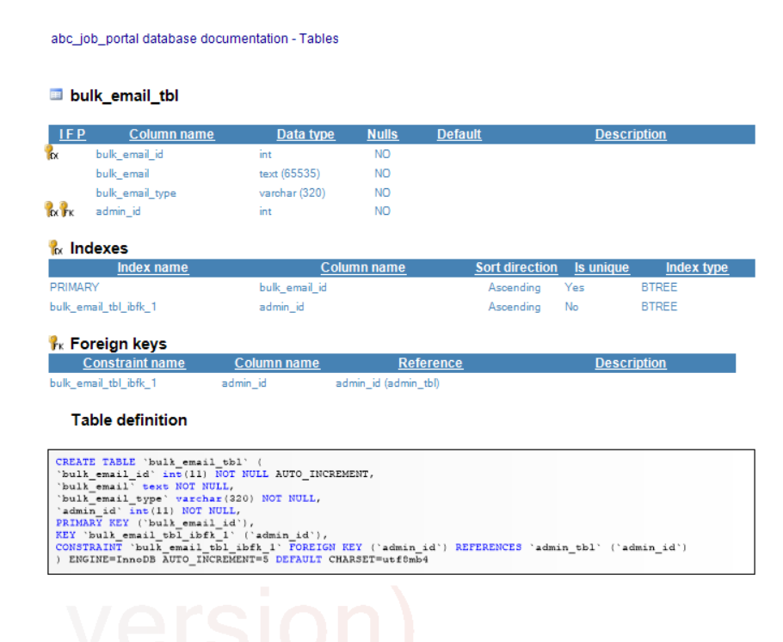

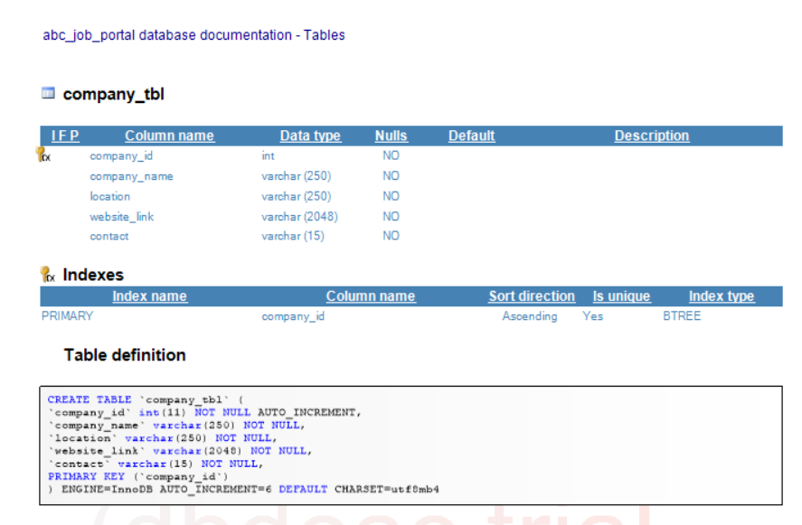

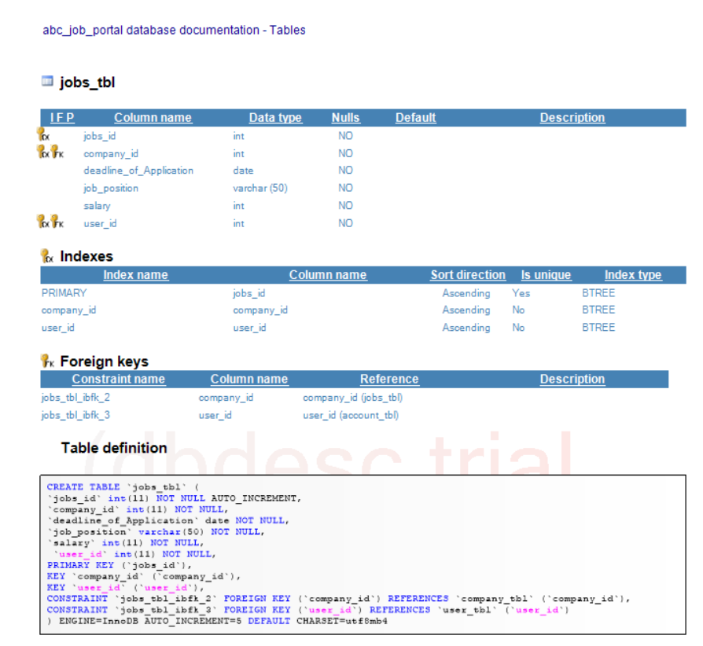

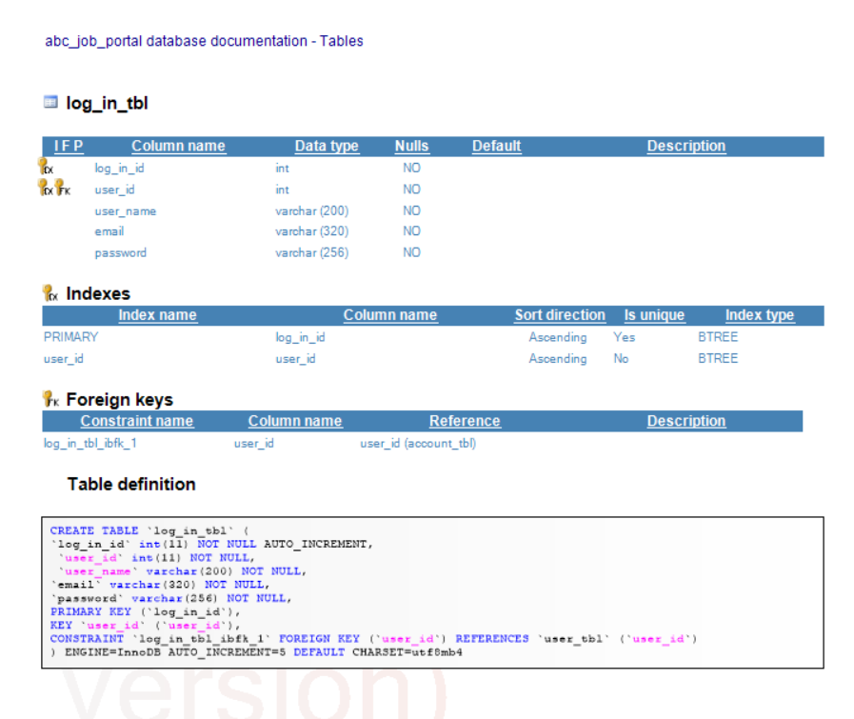

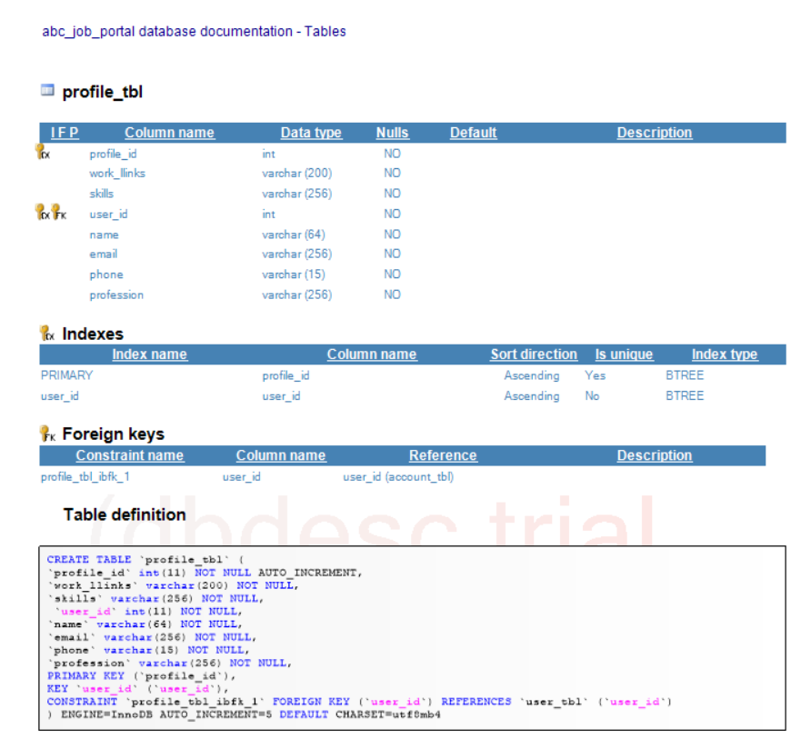

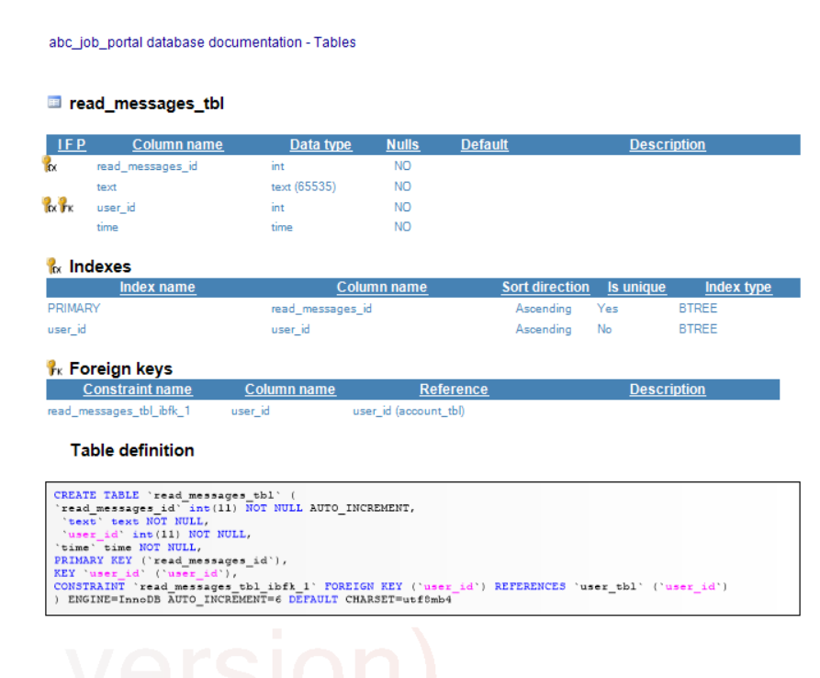

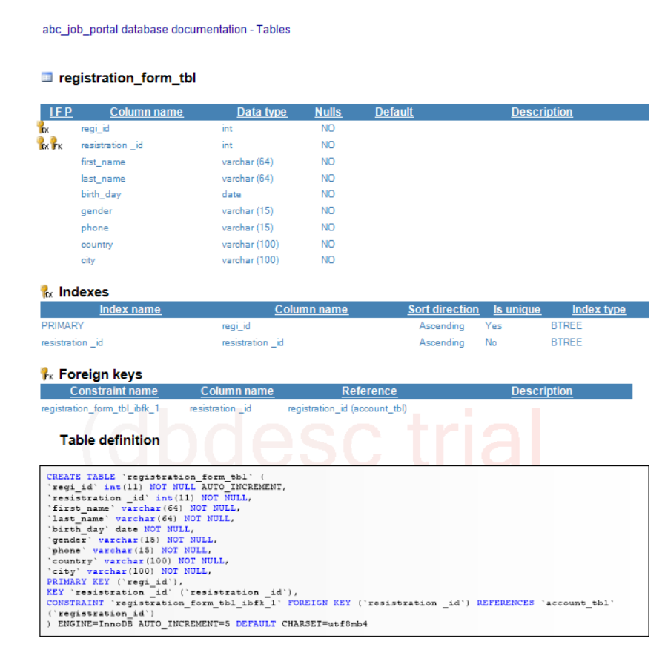

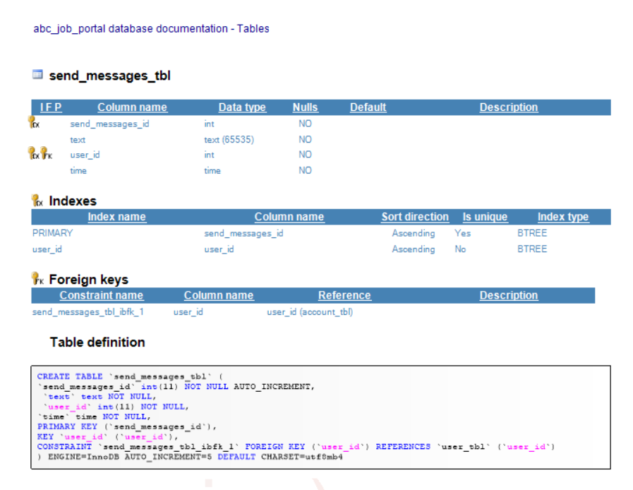

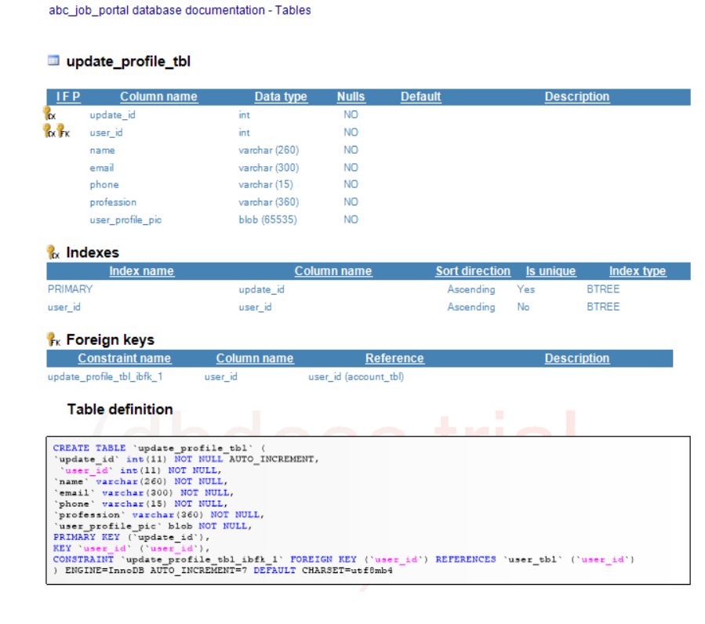

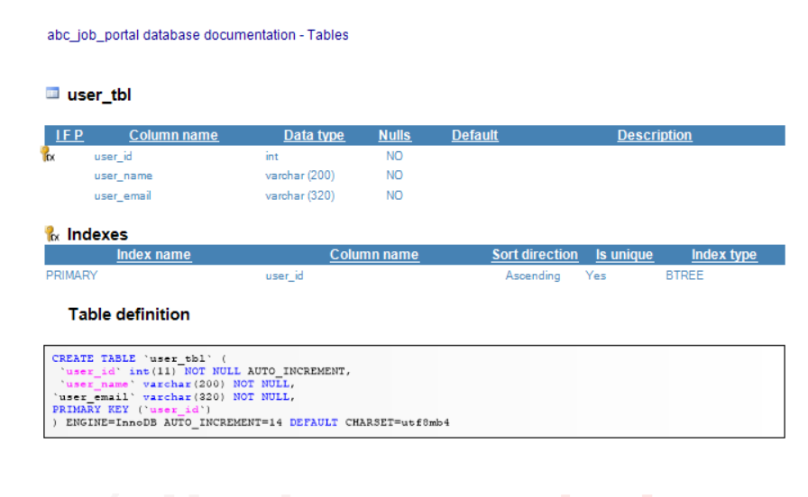

1. **Create a batch script to backup database & schedule it to run every 6 hours using windows task scheduler. Provide the script, along with the screen capture of Windows Task Scheduler**

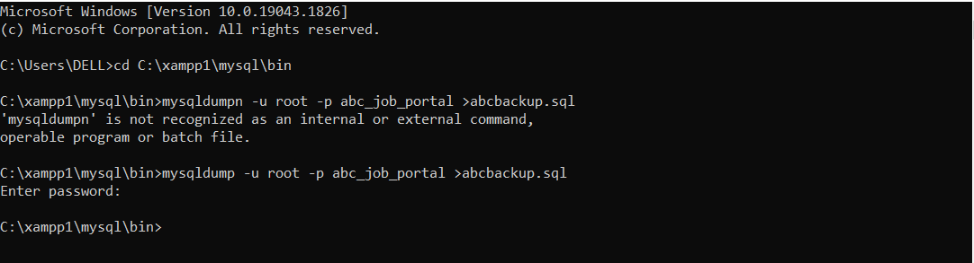

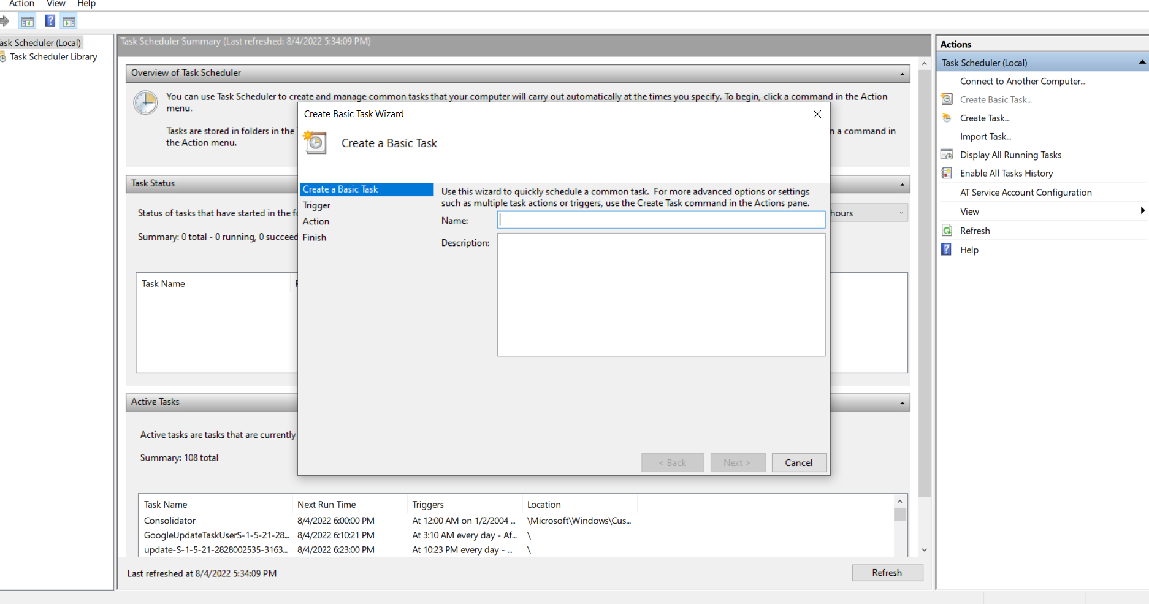

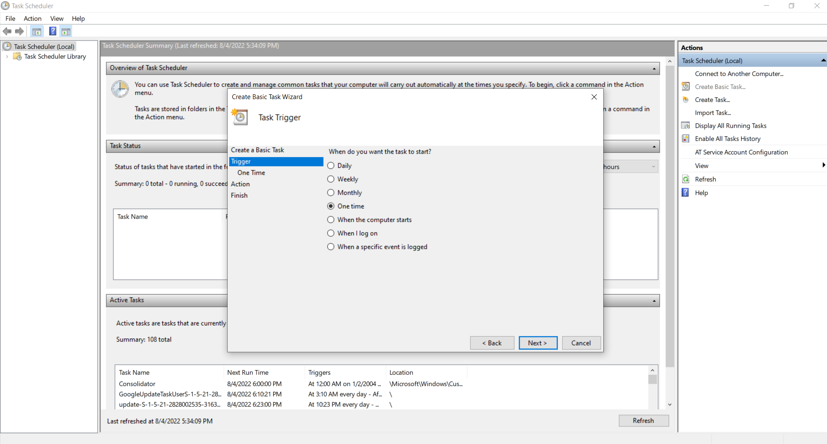

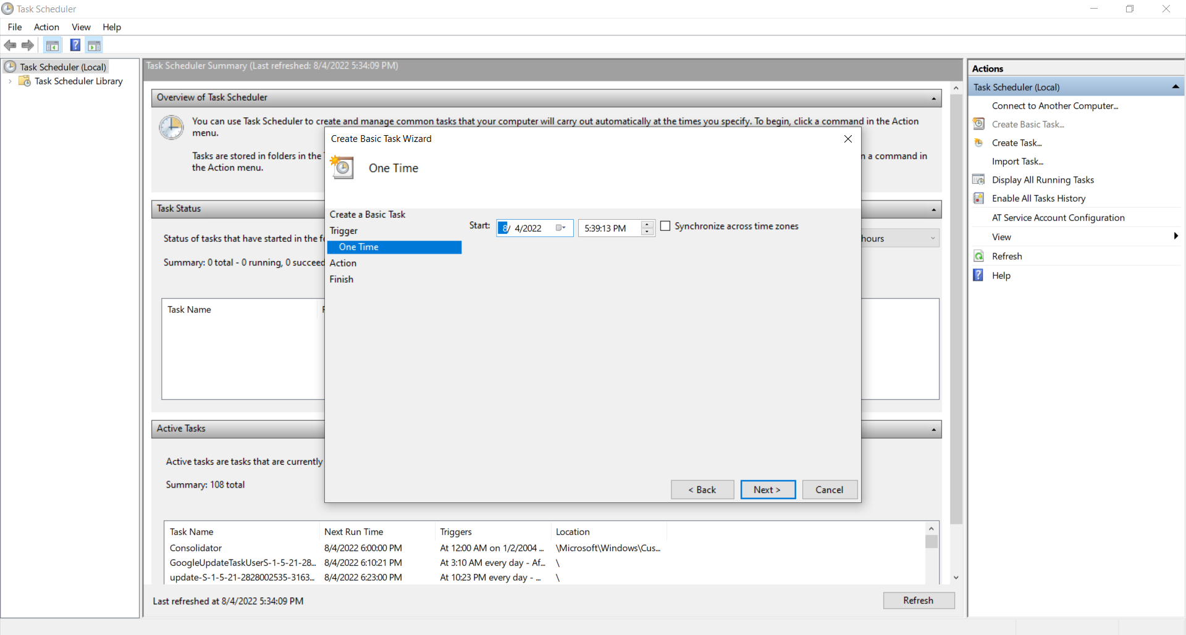

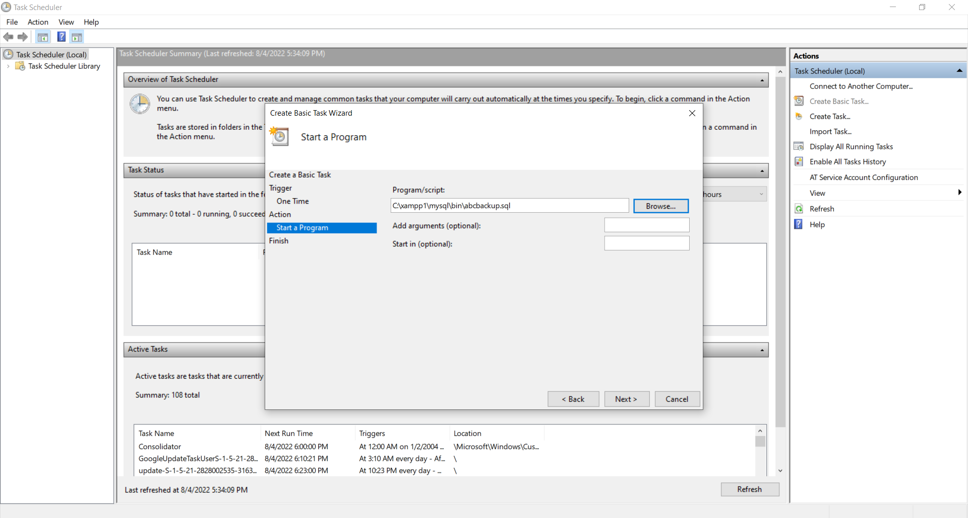

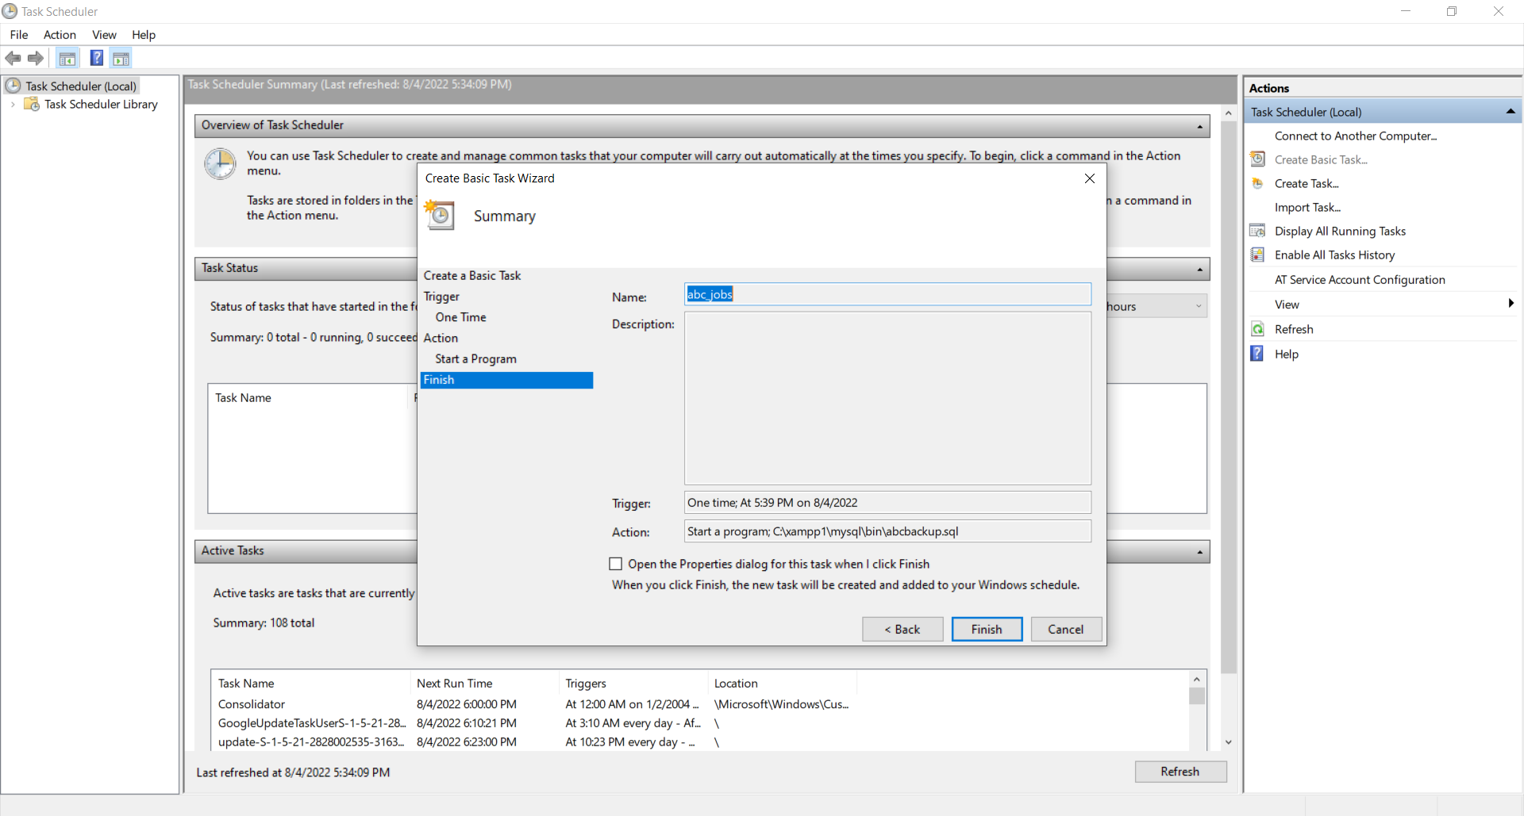

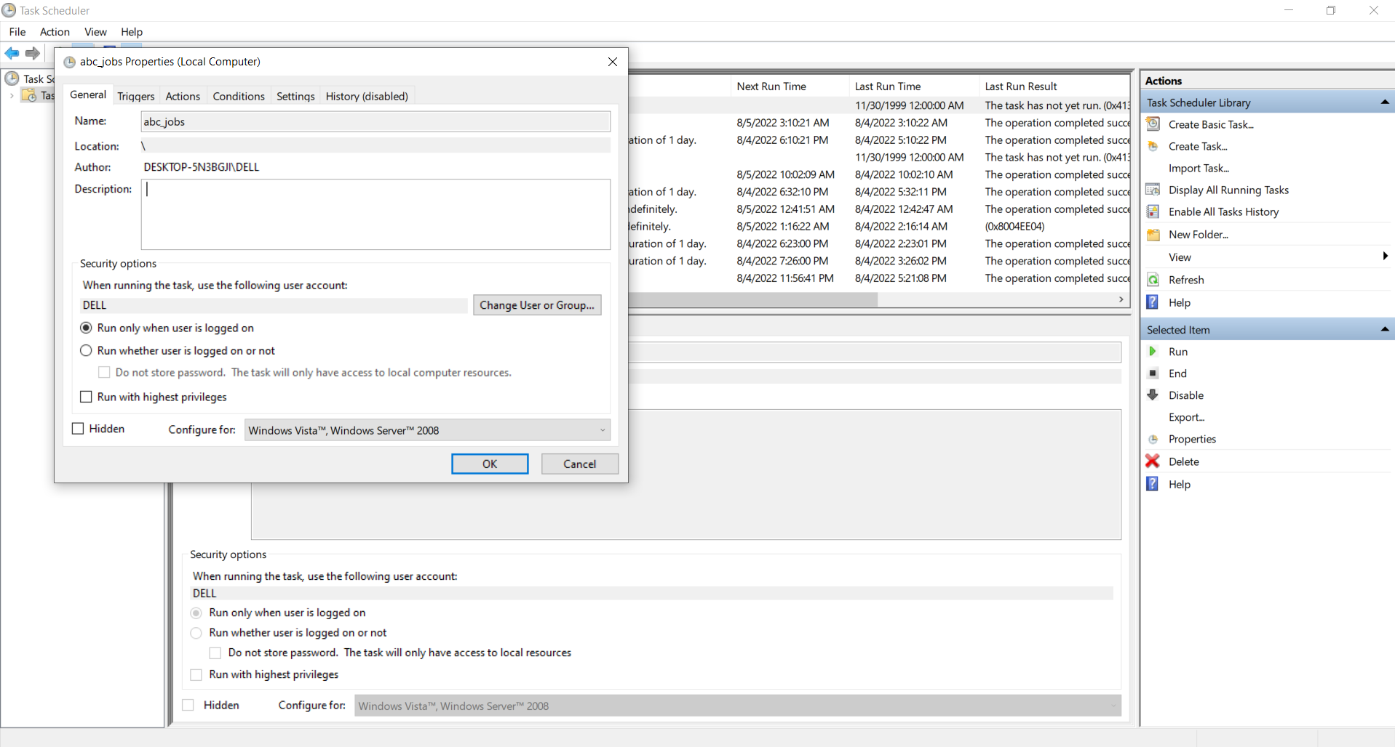

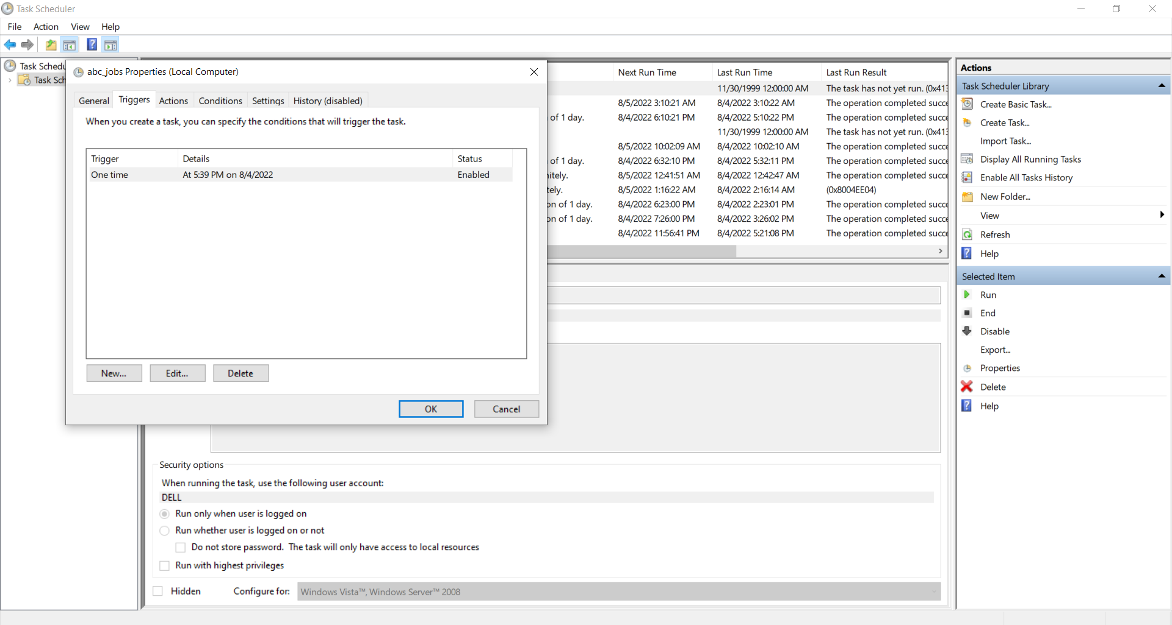

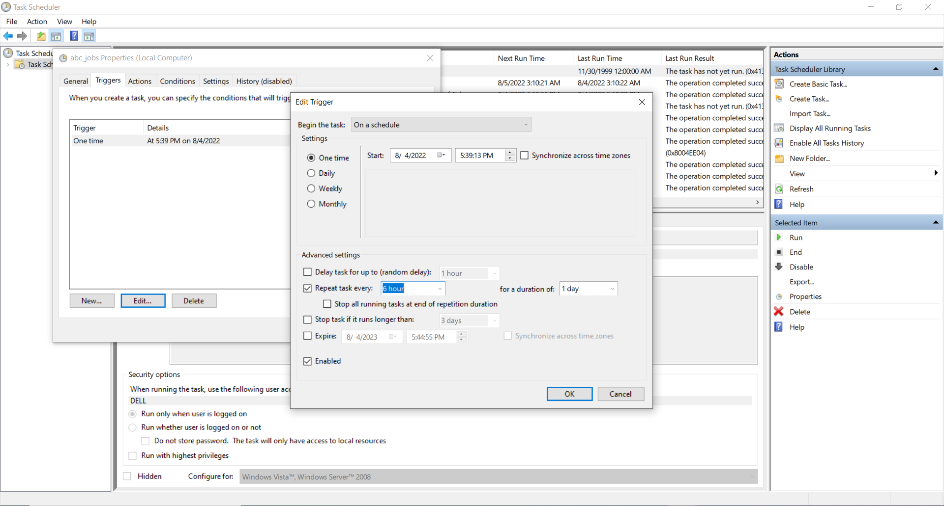

1. **Provide a Restoration script in case of failure**